Bamongram Resham Khadi Pratisthan (BRKP)
Annual Report
2022-23

REGD. OFFICE: - Vill. & Post- Bamongram, P.S. Kaliachak, Bamongram, Kaliachak-1 (W.B)
BRANCH OFFICE ADDRESS: - 78-B DDA Flats, Mata Sundari Road, New Delhi-110002
MOBILE: - 9868506876/ 9999098111

Bamongram Resham Khadi Pratisthan Profile
Contact Details
Address | Village & P.O. Bamongram, P.S. Kaliachak, Dist. Malda, West Bengal, India- 732206
Secretary | Md. Habibur Rehaman
Office phone | 9999098111
Email | bamongram123@gmail.com
Website | www.brkp.org
Legal Status
Pan No. | AAAAB4443R
NGO Darpan ID | WB/2017/0115454
Registration under | Societies Registration Act 1961
Society Regd. No. | S/83166
Registered on | 28th March 1996
Registered at | Kolkata, West Bengal
Income Tax Return | Organization files Income Tax Return every year to the Income Tax Dept. of Government of India
FCRA Notification No. | 147030022
80-G (5) (VI) | AAAAB4443RF20218
12-A No. | AAAAB4443RE20061
CA Name | P Chakraborty & Associates
Bank Details
FCRA Account:
Bank Name & Address | State Bank of India, FCRA Cell, 4th Floor, SBI, New Delhi Main Branch, 11 Sansad Marg, Delhi-110001
Account number | 39939570363
IFS Code | SBIN0000691
Non FCRA Account:
Bank Name and Address | Axis Bank, Chandni Chowk Branch, New Delhi-110006
Account Number | 91001035222540
Account Type | Savings
IFS Code | UTIB0000254

Preface
The Annual Report 2022-23 of “Bamongram Resham Khadi Pratishthan” (BRKP) constitutes a brief narration about the activities undertaken by the society during the fiscal year 2022-23. The report enumerates in it the sincere and effective attempts made by “Bamongram Resham Khadi Pratishthan” (BRKP) over the year to carry on with a number of its objectives embodied in the bye-laws. The report also expresses the extent of trust of the organization for the all-round development of the rural masses, the down trodden and the neglected sections of the society through a series of initiatives.
“Bamongram Resham Khadi Pratishthan” (BRKP) has worked in the areas of health, education, environmental protection, rural development, women empowerment and human rights. The organization aims to empower people through capacity building of the people.
A healthy mind in a healthy body is more desirable than anything else in life. “Bamongram Resham Khadi Pratishthan” (BRKP) has taken much care to improve the health and well-being through adequate awareness.
Social justice is never possible without proper equitable distribution of the country’s resources. “Bamongram Resham Khadi Pratishthan” (BRKP), therefore has put up much of its endeavours to see that the assistance and support of Govt. and Non-Govt. organizations meant for the public good reach their appropriate destinations.
It is our immense pleasure to place the Annual Report before all our patrons, well-wishers and also critics from whom we imbibe a lot for our strength. I express my sincere thanks to the resource persons and experts for sharing their views and experiences in various programs conducted by “Bamongram Resham Khadi Pratishthan” (BRKP). I also accord my heartfelt gratitude to the development agencies, govt. officials and well-wishers for the co-operation and support they have extended in materializing our objectives.
Md. Habibur Rahaman
President
BRKP
AIMS AND OBJECTIVES
- To provide opportunities for physical, moral, cultural and social education by organizing seminars, workshops, symposium, exhibitions, meetings, discussion and talks, cultural and sports meet, adventure program and other social gatherings/programs.

- To promote and develop entrepreneurship among the unemployed persons through vocational training, financial and technical assistance.

- To foster friendly relationships between rural and urban people and work for the weaker sections of the society.

- To enable children to be children, play, think, laugh and grow as children.

- To create socio-economic and cultural awareness among people.

- To organize people, especially women to take initiative for their own development.

- To motivate people for judicious utilization of local resources.

- To inculcate knowledge among the people to take action for restoration of ecological balance and eco harmony.

- To provide and arrange need based training to the rural folk, men and women, to upgrade their knowledge and improve their skill to become socio-economically self-reliant.
- To take action against environment pollution and harness the power of nature through proper utilization of renewable energy.
- To emphasise the need for education as the first step to fight against poverty.
- To work for the sustainable development of the people through participatory process.
- To promote interstate and international interactions and exchange of thought on global humanitarian interest without discrimination of class, color, creed or religion.

- To organize National Integration Camps in different part of India.

- To promote the concept of Gender Justice and Child Welfare.

- To organize educational tours including Mountaineering and Trekking for youth groups.

- To promote, propagate and educate about a healthy life style.

Activities of Bamongram Resham Khadi Pratisthan (BRKP)

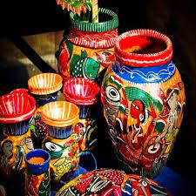
WORKSHOP/ SEMINAR FOR AWARENESS ON HANDICRAFTS
India is one of the major suppliers of handicrafts to the world market. Rapid globalization and increased competition make incessant demands on businesses to continuously upgrade existing products, processes, and business models to sustain the current and add new sources of revenue. Hence it is important to hold programmes (workshops and seminars) to prepare Handicrafts persons to anticipate, prepare, and respond to competition.
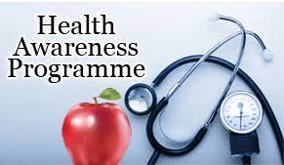
HEALTH AWARENESS PROGRAMME
BRKP focuses on diverse health topics to provide awareness to the communities and increase their levels of Health Literacy. Our focus areas are Health & Hygiene, Hand Washing, Menstrual Hygiene, Oral Hygiene, Nutrition, Dengue, Breastfeeding, Anaemia, Tobacco Sensitization, Immunization and Cancer.
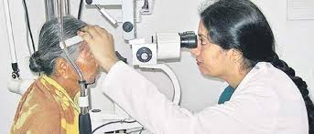
EYE CHECK-UP PROGRAMME
Eye check-up is an evaluation of the vision of the eyes and it is checked if a person has any eye-related disease or not. With the help of an eye test, the problem of eyes is checked as early as possible and can help one get the best treatment. An eye check-up camp was organized by BRKP to provide eye health services to the community members.

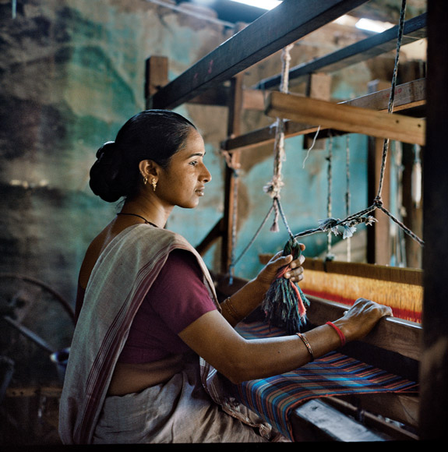
KVIC KHADI VOCATIONAL TRAINING PROGRAMME
Khadi or khaddar is hand spun and hand-woven cloth from India, Bangladesh and Pakistan mainly made out of cotton. The cloth is usually woven from cotton and may also include silk, or wool, which are all spun into yarn on a spinning wheel called a charkha. A course on khadi weaving was held in collaboration with Khadi and Village Industries Commission (KVIC).
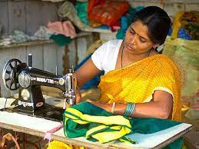
STITCHING PROGRAMME
BRKP organized a stitching & tailoring training programme for women of Kaliachak Block, Malda. The objective of this programme was to generate employment opportunities and supplement family incomes of the local women.
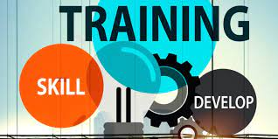
SKILL DEVELOPMENT TRAINING PROGRAMME
While there is an urgent need for skill training across the country, the absence of sufficient training avenues prevents the people from acquiring skill training and certification through formal channels. It is for this reason that BRKP organized a skill development training programme to enhance the skills of local residents so that they can increase their income.
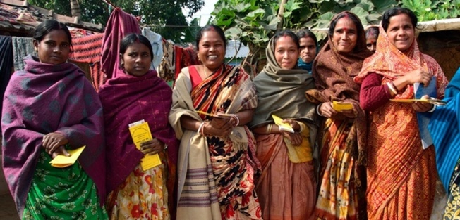
RURAL WOMEN CREATE SUREKHA AWARENESS PROGRAMME
An awareness camp on women surekha was organized by Bamongram Resham Khadi Pratisthan in the district Malda, West Bengal. A number of guest speakers attended the programme and delivered their lecture about the women surekha, care & protection. This program is generally based for the benefit of women who belong to the marginalized community and deprived segment of the society. The most important part of this event was that it was all women who initiated the program and participated in a huge number. More than 250 women attended the programme.

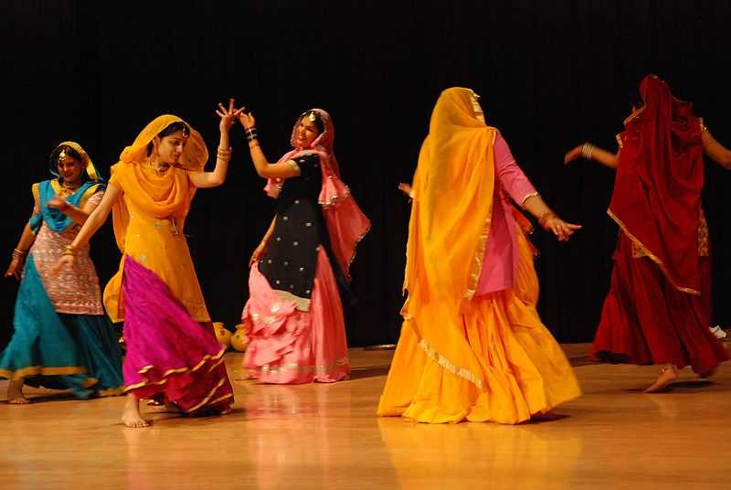
CULTURAL DEVELOPMENT PROGRAMME
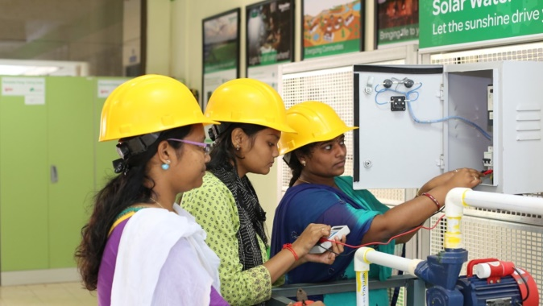
Culture is an umbrella term which encompasses the social behaviour, institutions, and norms found in human societies, as well as the knowledge, beliefs, arts, laws, customs, capabilities, and habits of the individuals in these groups. Culture is often originated from or attributed to a specific region or location. A cultural development programme was held by BRKP to restore the Indian culture and values in the local community.
ECONOMIC DEVELOPMENT PROGRAMME
An economic development programme was organized by BRKP to promote the possibility of self-employment or of getting a job by community members.
ATMANIRBHAR BHARAT AWARENESS PROGRAMME
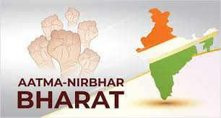
The Atmanirbhar Bharat Abhiyaan or Self-Reliant India aims to make the country and its citizens independent and self-reliant in all senses. BRKP organized an Atmanirbhar Bharat Awareness Programme to create awareness about the importance of self-reliance.
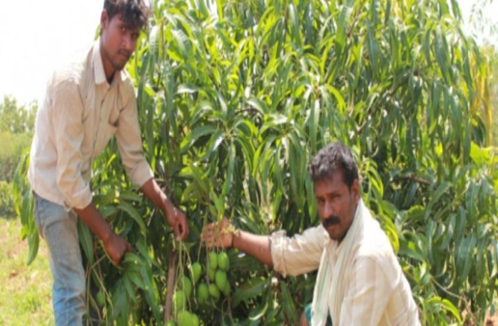
HORTICULTURE AWARENESS PROGRAMME
A one-day awareness programme on horticulture production and its importance was held by BRKP.

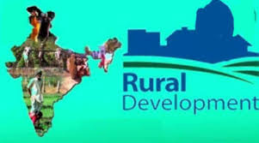
RURAL DEVELOPMENT PROGRAMME
The program's goal is to provide poor people with employment opportunities as well as opportunities to develop their skill sets in order to improve their living conditions.

ROAD SAFETY AWARENESS PROGRAMME
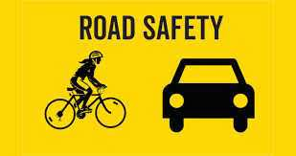
Road safety teaches people how to conduct themselves while driving or crossing roads. Road safety measures are aimed at reducing the risks of people getting involved in accidents in the first place. Following these measures, the chances of accidents, injuries and damage to property are vastly reduced. A Road Safety Awareness Programme was organized by BRKP for the local community members.
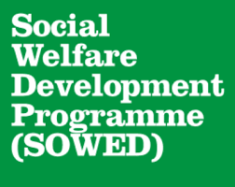
SOCIAL WELFARE DEVELOPMENT PROGRAMME
Social Welfare Development Programme aims at the welfare, rehabilitation and development of the vulnerable and disadvantaged population. BRKP organized a Social Welfare Development Programme to assist the poor people in the Malda district.

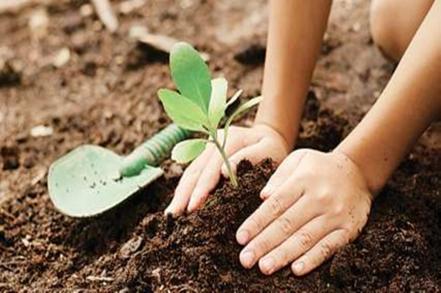
EARTH DAY / TREE PLANTATION PROGRAMME
Tree Plantation activities were organized by BRKP on Earth Day to highlight the importance of trees and of protecting the environment.

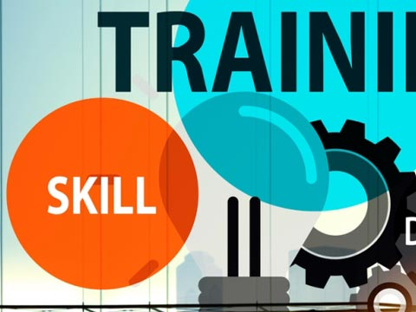
RETAIL TRAINING PROGRAMME
Retail Training Programme involves training on products, sales, marketing and customer services. BRKP organized a Retail Training Programme for the farmers and rural people to help them in selling their produce in the market.
TELECOM TRAINING PROGRAMME
BRKP organized a Telecom Training Programme for students and youth.

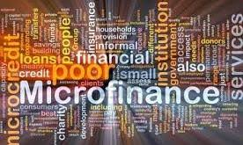
MICRO FINANCE PROGRAMME
Microfinance is a banking service provided to low-income individuals or groups who otherwise would have no other access to financial services. Microfinance allows people to take on reasonable small business loans safely, in a manner that is consistent with ethical lending practices. BRKP organized a Microfinance Programme to educate people about finance and help them get loans.
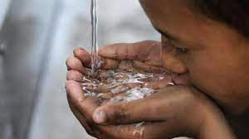
WATER ARSENIC PROGRAMME
As a consequence of reckless digging of underground water without optimal use of surface water the sources of underground water gets depleted gradually. It leads to greater input of toxic chemicals to human body via using and drinking of underground water. Among such toxic chemicals, and contaminant, arsenic is regarded as one of the most hazardous elements as it is responsible for causing several health hazards in term of severe types of cancer in skin, lungs, bladder and kidney. Water Arsenic Programme of BRKP is a programme to create awareness about the hazards of arsenic in water and of digging tubewells in selected areas to make available clean drinking water to the local residents.
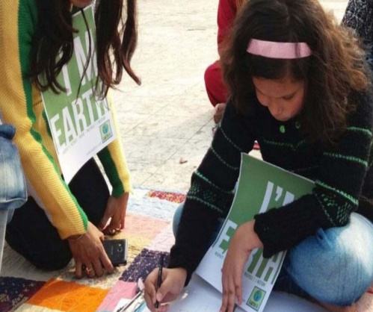
EDUCATIONAL DEVELOPMENT AWARENESS PROGRAMME
Education broadens the horizons of the mind and prepares young children to face challenges. It helps inculcate integral values, knowledge, intelligence and confidence. Educational Development Awareness Programme organized by BRKP aimed at creating awareness about the importance of education amongst participants.
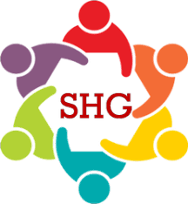
SHG FORMATION
Self Help Groups (SHGs) are small groups of poor people. The members of an SHG face similar problems. They help each other, to solve their problems. SHGs promote small savings among their members. The savings are kept with the bank. This is the common fund in the name of the SHG. The SHG gives small loans to its members from its common fund. BKRP helped form self-help groups to empower individuals.

